**Functional API**

Suppose we are given an image dataset of human faces and we are asked questions like:-

What is the Age of each person? (Regression Problem)

What is the Gender? (Classification)

What is the emotion of each face? (multi-class classification)

If we were to use our traditional approach i.e., Sequential API we had to make 3 separate models each addressing the specific problem. But in the industry that is not how it works. For ex, in amazon you will be given product metadata(Tabular Data), Product description and reviews(Text Data) and Product image(image dataset) and we will be asked the price of that product(Regression task). Hence, we need to connect and work with all the different types of data to carry out our task.

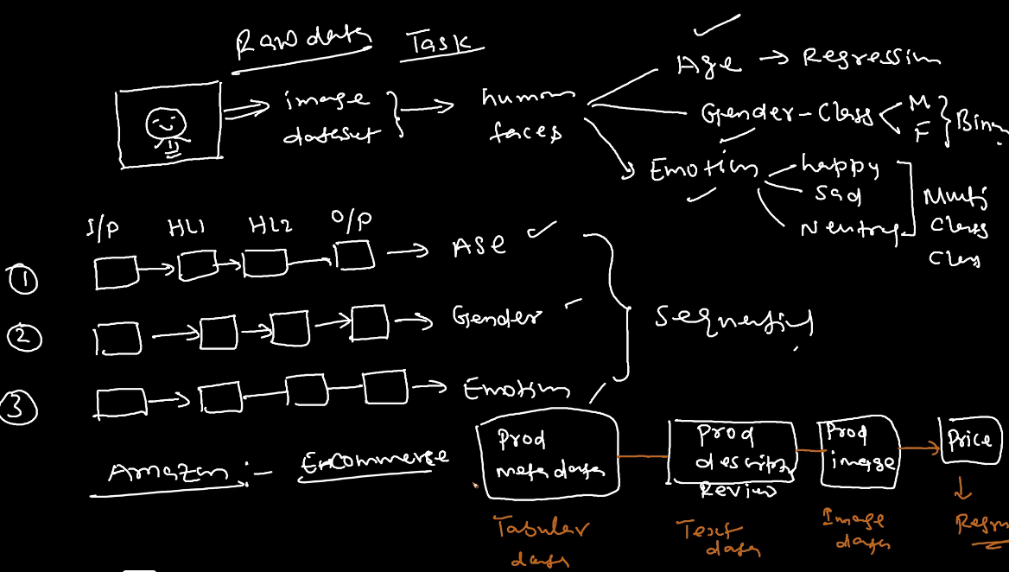

Since for the tabular data, we shall use MLP, for text data we shall use RNN and for image data we shall use CNN. Hence, we need to merge all these to find the solution to our problem. For such tasks, we need Functional API.

With Functional API it is possible to produce:

1. One output with multiple types of datasets.
2. Many outputs with one type of dataset.

